**Project Design Phase-II**

**Technology Stack (Architecture & Stack)**

|  |  |
| --- | --- |
| Team ID | PNT2022TMID21314 |
| Project Name | Estimate the crop yield using Data Analytics |
| Maximum Marks | 4 Marks |

**Technical Architecture:**

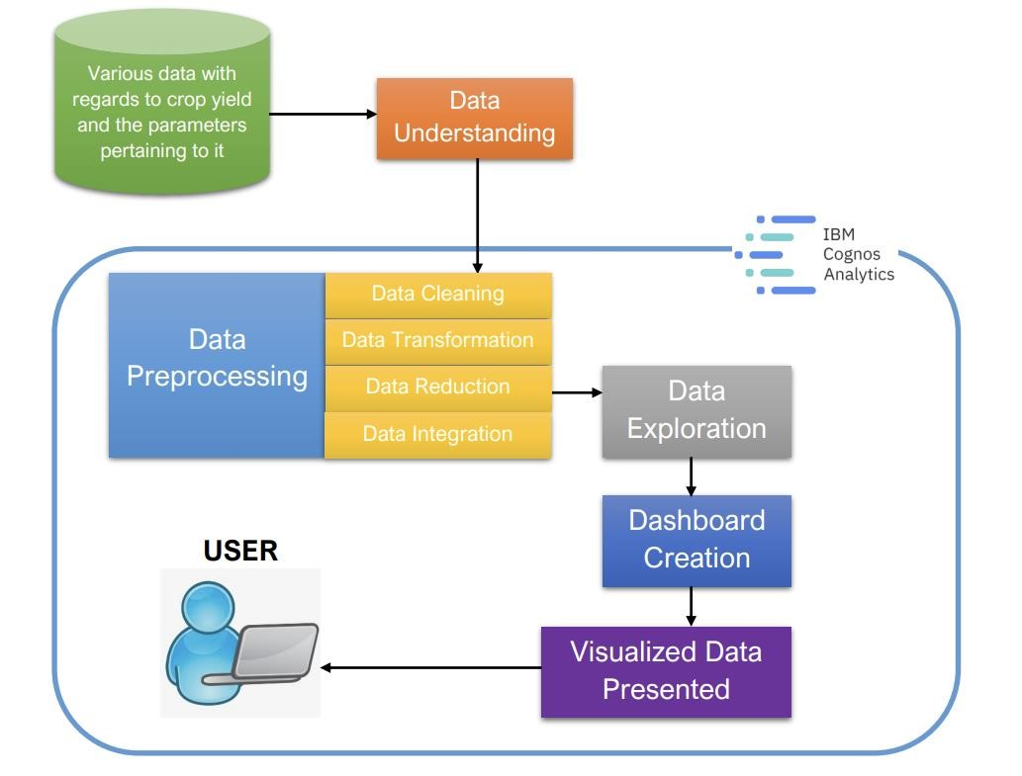

**IBM COGNOS**

**USER**

**&**

**ADMIN**

**USER L**

**OGIN / SIGNUP**

**D**

**ataset storag**

**e**

**in**

**C**

**loud**

**Table-1 : Components & Technologies:**

|  |  |  |  |
| --- | --- | --- | --- |
| **S.No** | **Component** | **Description** | **Technology** |
| 1. | User Interface | How user interacts with application e.g. Web UI, Mobile App, Chatbot etc. | IBM Cognos |
| 2. | Application Logic-1 | Logic for a process in the application | Java |
| 3. | Application Logic-2 | Logic for a process in the application | Cognos Assistant |
| 4. | Database | Data Type, Configurations etc. | MySQL, NoSQL, etc. |
| 5. | Cloud Database | Database Service on Cloud | COGNOSCS. |
| 6. | File Storage | File storage requirements | IBM Block Storage or Other Storage Service or Local Filesystem |
| 7. | External API-1 | Purpose of External API used in the application | IBM Cognos Analytics REST API |
| 8. | External API-2 | Purpose of External API used in the application | - |
| 9. | Infrastructure (Server / Cloud) | Application Deployment on Local System / Cloud | IBM Cloud – IBM Cognos Analytics |

**Table-2: Application Characteristics:**

|  |  |  |  |
| --- | --- | --- | --- |
| **S.No** | **Characteristics** | **Description** | **Technology** |
| 1. | Open-Source Frameworks | List the open-source frameworks used | IBM Cognos Framework Manager |
| 2. | Security Implementations | List all the security / access controls implemented, use of firewalls etc. | Security architecture present |
| 3. | Scalable Architecture | Justify the scalability of architecture (3 – tier, Micro-services) | Business Intelligent architecture |
| 4. | Availability | Justify the availability of application (e.g. use of load balancers, distributed servers etc.) | Present on cloud and is present on demand |
| 5. | Performance | Design consideration for the performance of the application (number of requests per sec, use of Cache, use of CDN’s) etc. | Highly available and fast processing |